Q1) Display Databases
Login to MySQL and write a query to display all databases already present in the system.
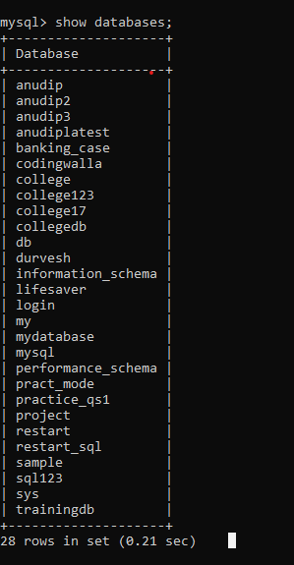

Q2) Create countries Table
Write an SQL query to create a table named countries including columns country_id,
country_name and region_id.
After this display the structure of table.
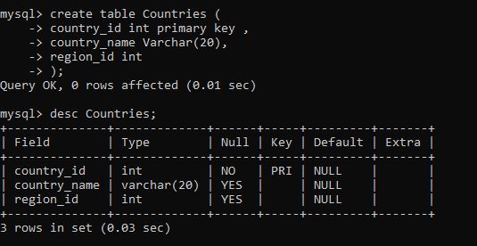

Q3) Create jobs Table with Constraints
Write an SQL query to create a table named jobs including columns job_id, job_title,
min_salary, max_salary.
Apply constraints:
- job_id must be Primary Key
- job_title cannot be NULL
- max_salary must not exceed 25000
